# ISTE 140 Final Practical Exam 2221

## Due: Wednesday 11/30 at 9:00 pm in the MyCourses Assignment

## Overview:

This practical exam is a checkup on the design and technical skills that you are learning in the class. This test should not be particularly hard, but it is going to ask you to combine several of the skills we have learned as discrete topics to create useful web pages. To complete this test you are going to have to use your design skills to create three new layouts and your technical skills to create the code to make the designs function as a responsive page.

While I started with a working responsive page I have deleted some of the code that made it responsive (I have left comments where I deleted code). You will have to first fix this, then build your three versions.

I have deleted four sections of code in the Index.html and three in the styles.css. I have placed comments where I deleted code.

## Exam Policies:

* To complete this exam you may use any resources at your disposal except for other people.
* I encourage you to search the web to get inspiration for both your designs and HTML and CSS techniques.
* You must code all the HTML and CSS by hand in an editor of your choosing (you may not use an automated coding environment).
* **Setting up your directories and subdirectories on Solace is part of the test as is submitting a URL and points will be given for following directions on how to deploy your code.**

## Troubleshooting:

Don’t forget your troubleshooting skills.

* Set the title first so you can see that you are actually making changes to your page in HTML.
* Make sure your css file is actually impacting your HTML. You can do this by setting a very obvious style in your css like background_color.

body {

background‐color: #F5F5DC

}

* If your styles.css is not actually impacting your page, it is usually a problem with the path.
* Be sure to check the extension on your images, not all images are .jpg…
* Make a small number of changes, then upload and test.
* Remember the difference between block and span elements.
* If you are not sure of the syntax, check w3schools, and use their try it examples.
* As this is to be a responsive page, you are going to have to set up two layouts for each design, one for a narrow, mobile friendly device and one for a wide, laptop screen.

## Practical Exam Deliverables:

I am giving you an Index.html, a styles.css and several image files that will produce a basic tourism page for the country of Kosovo. Your goal is to play the role of a web designer who is working with the Kosovo Tourism government Ministry to create a new tourism website. The Ministry is interested to see your vision for the web site and has given you some content and images to create three different layouts for the Ministry to decide from. The winning layout will serve as the basis for a whole bunch of new pages. While the site will be primarily funded through Google Ads, you do not have to worry about making room for the ads.

For this practical exam you need to use the provided content to create three different versions of pages using the same content and images. Each version will actually include two pages, one narrow page for mobile devices and one wide screen for laptop size devices. However, since you do not have as much room to work with for the narrow page, you might want to use the same stacked box version as in the image to the right: The changes between your versions might be more changes in colors than layouts.

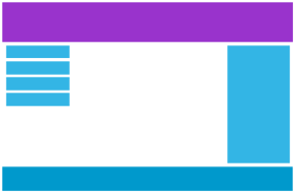

For your laptop version you might use something like to the left:

If you were to redo the layout of the Index.html and styles.css files to create a layout similar to the left, that would count as one version. To create a second version you could move the images and content to a different part of the page (lower left, maybe) change the description to a different box, and change the background color and maybe the font. This would count as a second version. The goal is to change the layout and the different colors and fonts to give the Ministry a new “look” to choose from.

You can also do things like:

* Add more images
* Use the grid command to create columns
* Add a summary section or a section on “Getting Around Kosovo” etc.
* Check out other tourism sites to see what ideas you can find.
* Use your creativity to make three layouts that you like and find useful.

## Setting up your environment on Solace:

**The main deliverable I want from you in the MyCourses Assignment is a set of URLs on Solace. To be as efficient as possible in completing your work you must set up a directory structure the same as mine below on your laptop.** Then you can do your development on your laptop with your editor. When you are done you can copy everything (directories and files) onto Solace with Filezilla. When you do your work this way Filezilla will copy your files and your directories at the same time. Doing this correctly will be part of your grade. Personally I would copy the starter files into the same directory structure on your laptop, then I would go in and edit each version to create the versions that you will copy to Solace.

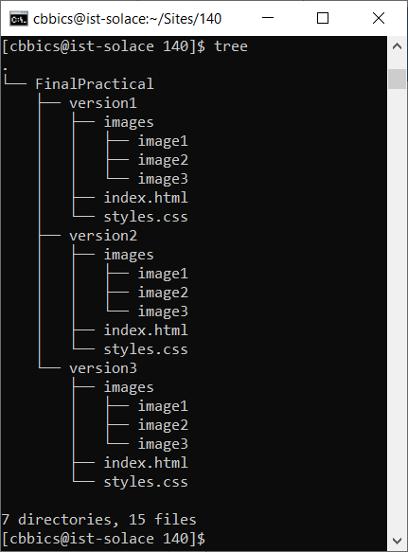

## Wireframes:

While it is always a good idea to build wireframes first before you do any coding, they are **not** required for this assignment.

## Deliverables:

**I only require three deliverables for this final practical. URLs on Solace for each of your three versions of the page in the correct directory structure.**

## Original Version:

This is what the original pages look like before you change.

